Short-beaked common dolphin (Delphinus delphis) diet: amount and composition.

Short-beaked common dolphin (Delphinus delphis) is the main species of cetacean in the Iberian Peninsula. Due to the relatively high abundance of common dolphins in this region and the high food intake needed by marine mammals, dolphins might have an important impact in the populations of their main prey species and in the ecosystem. The fourth most abundant prey species of common dolphin in the Iberian Peninsula is the European hake (Merluccius merluccius) (Santos et al., 2013). Although hake is recorded in the diet of various predators such anglerfish (Lophius spp.), hake itself (Preciado et al., 2008) and cetaceans as bottlenose dolphin (Tursiops truncatus) (Santos et al., 2013), total amount consumed by common dolphins may be enough to affect of the stock dynamics of hake.

Since European hake is one of the most important fishery resource for the Iberian Peninsula, competition between marine mammals and fisheries should be taken into account. Construction of multiespecies models allow us to know the impact of common dolphin in the ecosystem and in particular their interaction with the hake population and fisheries. To integrate common dolphin in multiespecies models besides knowing their biological parameters and life history, is necessary to have good information on the composition of their diet and energetic requirements.

The diet of common dolphin has been described from the examination of the stomach content of animals stranded and bycaught in the Iberian Peninsula, both in Galicia (NW Spain) (Santos et al., 2007; 2013) and in Portugal (Silva, 1999). 514 dolphins were analyzed from 1991 to 2008 from Galician coast and 50 from 1987 to 1997, in Portugal. Composition of the diet was different between areas and energy content was calculated for the total stomachs contents of each area based on energy density data provided by Spitz et al. (2010). Dolphins diet in Galicia was less caloric (5543 kj/kg) than Portuguese diet which energy content was 6862 kj per kg of stomach content. Since only hake and sardine are the species of our interest, the energy content of the rest of the food was calculated subtracting with all other species together to later analysis. Energy contents of the other food were 5234 kj/kg in Galicia and 5515 kj/kg in Portugal, resulting the mean of both 5375 kj/kg.

Proportion of hake in the common dolphin diet

Hake proportion in weight of the total stomach content was bootstrapped and the mean obtained was 5.71% (95% IC. 4.16 - 7.47). Portuguese hake proportion was also bootstrapped, however the individual content of the stomach dolphins are not available, just the mean proportion of the total dolphins. Therefore, a log-normal distribution of the hake proportion was assumed, with same standard deviation as the Galician dolphins and same mean as that provided by Silva (1999). Both parameters transformed for use in a log-normal distribution. Proportion of hake in the diet of Portugal was 2.09% (0.96 – 3.95). Due to the considerable difference between consumption in Galicia and Portugal, the means and confidence intervals were recalculating. Bootstrapped values, 1000 in each case, were put together to estimate a new average and confidence interval to the whole area. Mean proportion of hake in the whole area was 3.89% (1.10 - 7.01).

The estimated importance by weight of the hake was also converted into energy values based on energy density data provided by Spitz et al. (2010). Hake energy content and its range is 3700 [3400 - 3900] kj/kg. The energy which hake represents in 1 kg of food for an average dolphin is 211.27 kj/kg [141.44 - 291.33] for Galicia and 77.33 kj/kg [32.64 – 154.05] for Portugal. The mean for the whole area was 143.93 kj/kg [37.4 – 273.39].

Proportion of sardine in the common dolphin diet

Santos et al. (2013) noticed that presence of hake in the stomaches of the dolphins was negatively related to sardine recruitment, which is one of the main prey species in common dolphin diet. Therefore, sardine proportions in the diet were calculated as well as the preferences of the sardine length classes.
Sardine proportion in Galician dolphins was bootstrapped as explained above for the hake. Sardine proportion in Portuguese dolphins also was calculated as the same form as the hake. Consumptions were 11.44% (8.88 - 14.06) for Galicia and 43.48% (40.96 - 46.15) for Portugal. As explained at the hake estimates, all data were put together and the resulting mean an confidence interval for the whole area were 27.47% (9.49 – 45.77).

The energy that sardine represent in a common dolphin stomach was transformed from the proportion in the stomach. Sardine energy content and its range provided by Spitz et al. (2010) is 8700 [7500 - 10100] kj/kg. Therefore, energy which sardine represents in 1 kg of food for an average dolphin was 995.28 kj/kg [666.00 – 1420.06] for Galicia and 3782.76 kj/kg [3072.00 – 4661.15] for Portugal. The mean for the whole area was 2389.89 kj/kg [711.75 – 4622.77].

Daily food intake

Daily energy intake for common dolphin has been approximated in the literature based either on experimental studies (e.g. respirometry), relationships with the basal metabolic rate (BMR), or direct estimates of food consumption in the wild or in captivity. Three indices can be used for estimate energetic consumption for common dolphins, two based only in the dolphin weight: Kastelein et al. (2000) and Innes et al. (1987), and another based in the weight of the dolphin as well, but also in the energetic content of their diet: Kleiber (1947).

Length and weight distribution of the Galician dolphins were used to estimate the energy and food intakes both for the Galician and for the Portuguese dolphins. Only was possible to measure 407 of the 518 dolphins and sexing 491. The lengths ranged from 121 to 240 cm and the corresponding weight was estimated for each of this dolphins by applying previous calculated length-weight relationships based on data collected from several European countries (Pierce et al., 2005). When sex data was available, male and female length-weight relationships were applied, if not, a general model for both sexes was applied. These lengths corresponded to weights ranging from 20.7 to 139.9 kg (average weight = 70.97 kg). Frequencies of the lengths and their corresponding weights showed normal distributions (see Fig. 1).

The three energy indices give us different figures of daily food intake. While the Kastelein and Innes indices gave the same figures for Galicia and Portugal, 6.49 kg/day (95% CI, 6.38 – 6.59) and 4.82 kg/day (4.71 – 4.94) respectively, the Kleiber index use the energy content of the diet in each region and, due to differences of this, the food intakes obtained were 5.55 kg/day (5.42 – 5.68) for Galicia and 4.38 kg/day (4.27 - 4.48) for Portugal. These values correspond with the mean of the food intakes estimated for all the dolphins analyzed and confidence intervals were bootstrapped, based on 1000 runs using the boot and boot.ci commands in the package boot (Canty and Ripley, 2001) in R 2.13.0 (R Development Core Tean 2008).
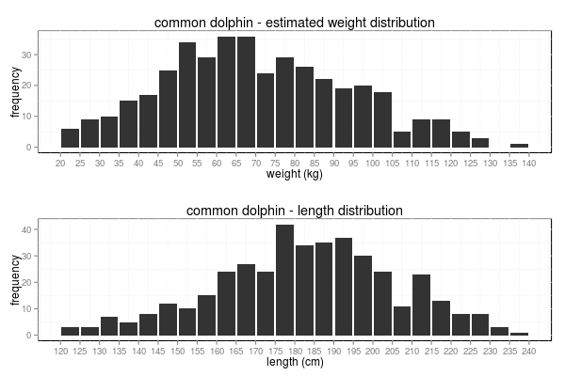
Fig. 1: Estimated weight distribution (upper figure) and length distribution (lower figure) for common dolphins whose stomachs were analyzed.
Daily food intake is quite different depending on the index used, therefore, food intake was estimated for all dolphins with the three indices and for the two areas and the resulting values were fitted in a new linear model (Fig. 2). As has been previously explained, the Kastelein and Innes indices, and Kleiber figures were different for Galician and Portuguese dolphins. Therefore, four different consumptions have been used to fit the model. The mean food intake was 5.31 kg/day (5.20 – 5.41) for an average dolphin and the kilograms of food consumed per dolphin kilogram was 0.075 kg (0.073 – 0.076). The linear regression resulted as follows:

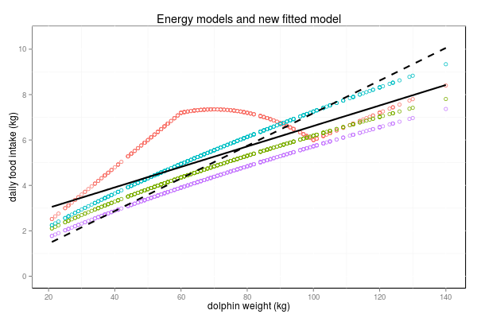
whereis the daily food intake of a given dolphin andis the dolphin weight in kg.

Fig. 2: Daily food intake calculated with the Kastelein index (red dots), with the Innes index (green dots), with the Kleiber index for Galicia (blue dots) and for Portugal (purple dots). The regression model fitted to all these values is represented as a solid dark line, and the same regression but forcing the intercept to be zero is represented as a dashed dark line.

If this regression want to be used to model the predation in a Gadget model, the intercept must be zero and it should be refitted only with one parameter which represents the slope, as is shown bellow:

whereis the daily food intake of a given dolphin andis the dolphin weight in kg.

Gadget model uses predator length to estimate consumption with the following function:

where is the maximum possible consumption for the predator on the current timestep for a given length of predator, is the length of the predator andandare constant parameters, since and are parameters associated with temperature and bypassed in the case of dolphins since the influence of temperature in the feed is low in warm-blooded animals. Therefore, length-weight relationship for all dolphins (males and females together) was transformed to an exponential function becoming which was substituted in the food intake function and the resulting the following equation:

where in Gadget consumption function , and

Relationship between lengths of dolphins and their preys

The relationship between the length of the dolphins and the length of their preys was analysed. Is expected that the largest dolphins eat larger hakes, however, although this occurs to some extent, dolphins are opportunistic and prey on a wide range of lengths. A regression model was fitted to this relationship, the slope was slightly positive but, due to the high dispersion of the data the adjusted R-squared was 0.015. Length estimated of one hake was higher than 60 cm and was removed for the data to be considered an outlier. The resulting regression was as shown below:

whereis the prediction of the hake length andis the dolphin length.

The scatterplot and the fitted regression of this relationship are shown in Fig. 3. Histograms of lengths frequencies are plotted as well both for hake and dolphins. Hake length frequencies are normal distributed, lengths ranged from 2.50 to 60.84 cm but 95% of hakes measured from 6.11 to 34.57 cm and the range between 10 and 20 cm comprises more than half of the preyed hakes.

Same analysis was carried out for the Sardine. Sardine lengths ranged from 15.66 to 22.61 cm and 95% quantile from 16.70 to 20.18 cm. Distribution of sardine lengths preyed by dolphins was almost constant for all dolphins lengths and regression fitted to this relationship showed a small positive increment and the adjusted R-square of 0.014 (Fig.4). Fitted regression was as follows:

whereis the prediction of the sardine length andis the dolphin length.
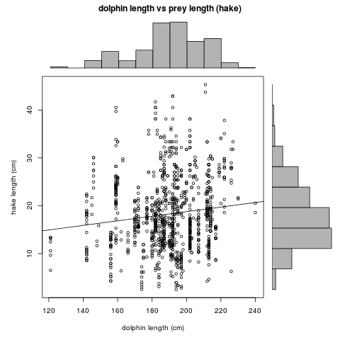
Fig. 3: Relationship between dolphins length and hake length. Fitted regression. Histogram of the length dolphins distribution, on the top. Histogram of the length hake distribution, on the right.
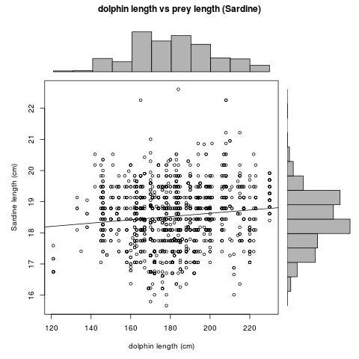
Fig. 4: Relationship between dolphins length and sardine length. Fitted regression. Histogram of the length dolphins distribution, on the top. Histogram of the length sardine distribution, on the right.

Assuming that the dolphins were randomly analyzed from the total observed stranded dolphins in the same period, population structure of analyzed dolphins will be the same as the one of the total population of dolphins in this area. Therefore, the hake length frequency distribution observed in these stomachs will be the same as the preyed by the total dolphins population.

Based on these assumptions, length distribution of the preys of a given dolphin can be obtained by applying a probability function equal to that observed in the stomach samples, regardless of the length of the dolphin. Probability density function of the length distribution of the preys found in the total stomaches analyzed was calculated applying the non-parametric Kernel density estimation (KDE). Then, a GAM was fitted to the density estimated values in order to create a prediction function to estimate the probability of occurrence of each length class of hake (Fig. 5) and sardine (Fig.6).

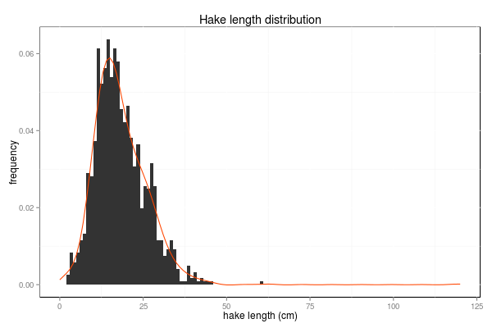
Fig. 5: Hake length distribution in the stomach content of the total dolphins analyzed. Kernel probability density function (red line).

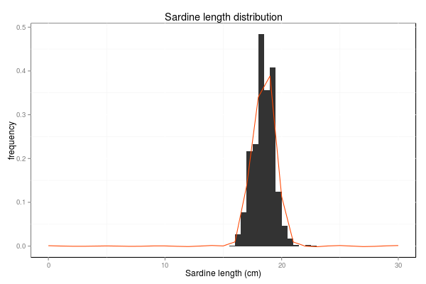
Fig. 6: Sardine length distribution in the stomach content of the total dolphins analyzed. Kernel probability density function (red line).

However, since dolphins prey on the small hakes, usually on recruits less than one year old, is expected that the length average and the distribution of the preyed hakes varies along the time. Analysis of the length distribution and estimation of their associated density function was conducted for each quarter of the year. In Fig. 6 distribution change throughout the year where the smaller hakes are found in the third quarter, corresponding with the period after the higher peak of the spawning, them average of the distribution increases along with the growth of hake. However, although trend is quite clear, the dispersion is high, likely because the European hake spawning is not concentrated in one year period.
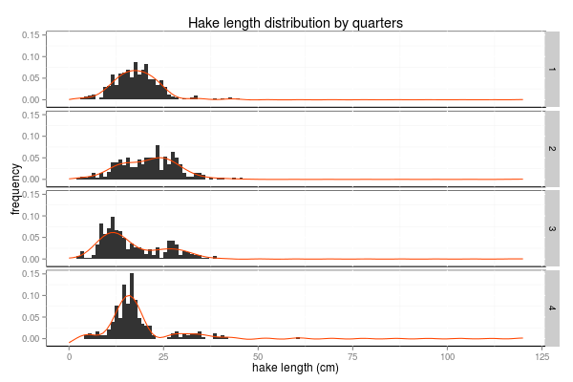
Fig. 6: Hake length distribution split by quarters. Histogram of length distribution of each quarter and probability density function

Same analysis by quarters was carried out for sardines but lengths distribution and their respective means did not show a clear variation throughout the year as the hake (Fig. 7).
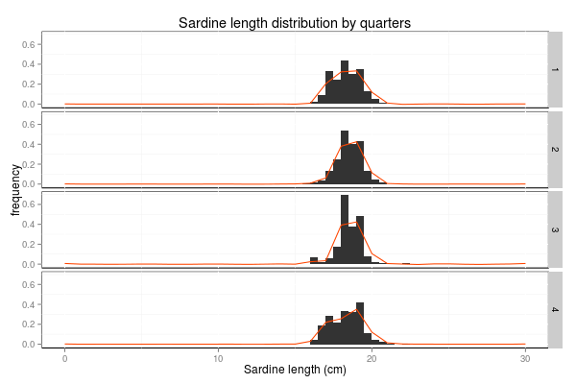
Fig. 7: Sardine length distribution split by quarters. Histogram of length distribution of each quarter and probability density function.

As the length distribution, abundance of hake susceptible to being preyed may vary throughout the year. In Fig. 8 box plots of relative abundance of hake (in number), in dolphins stomach are shown below the histograms of hake distribution. Total weight is shown in the right plots as well. Also in this graphics we can see, as the length distribution, abundance is not the same throughout the year.
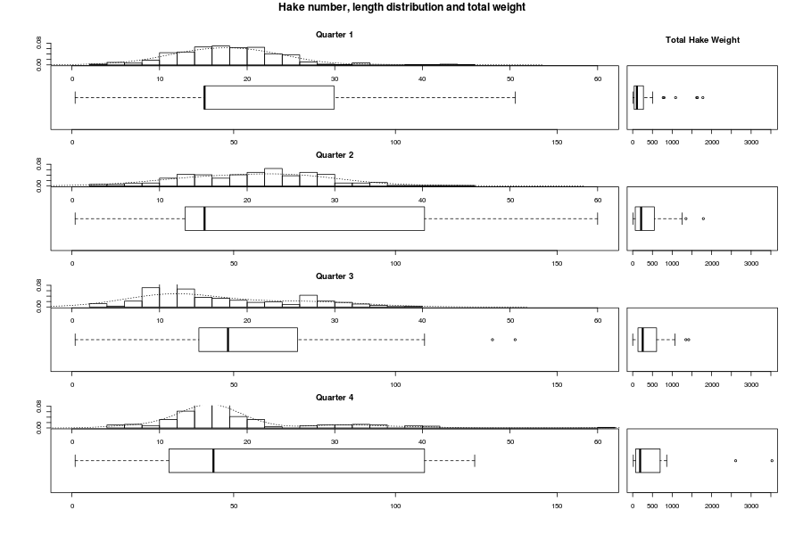
Fig. 8: Length distribution of hake in dolphin stomachs (histograms), mean number of hakes per stomach (left boxplots) and their corresponded weight (right boxplots). All these data divided by quarters.

Average proportion of hake in dolphins diet has been calculated more accurately by conducting bootstraps for the mean. 95% confidence intervals were bootstrapped in the same way as well. In Fig. 9 proportion of hake with 95% CI are presented for each quarter for both sexes as well as for males and females individually. The maximum consumption occurs in the second quarter but in the third and fourth show an opposite trend, increasing in males and dropping in females.
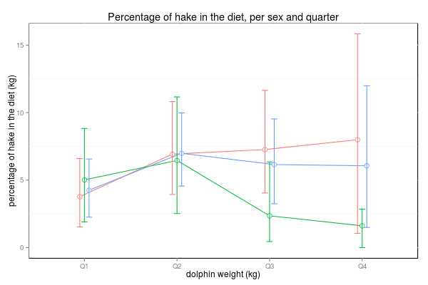
Fig. 9: Percentage of hake in dolphins diet and 95% CI. Consumption divided by quarters and sexes. Both sexes together (blue line), males (red line), females (green line).

Proportion of hake en each quarter and sex, confidence intervals and the number of dolphins analyzed in each case is shown in Table 1.

Table 1: Mean proportion of hake en each quarter and sex, confidence intervals and the number of dolphins analyzed.

Long-term variation in diet, relation to prey abundance

ZIMB GAMs were conducted by Santos et al. (2013) to hake numbers in Galician dolphin stomachs. Hake abundances in stomachs showed significant interannual and seasonal variation with increasing importance of hake in the stomach from 1998 onwards. However, data dispersion was high and root transformation was applied to fit the model (Fig. 8). Two stock variables (recruitment and SSB) were substituted in the models, both hake recruitment and hake SSB were significantly positively related to importance for hake in dolphin stomachs.
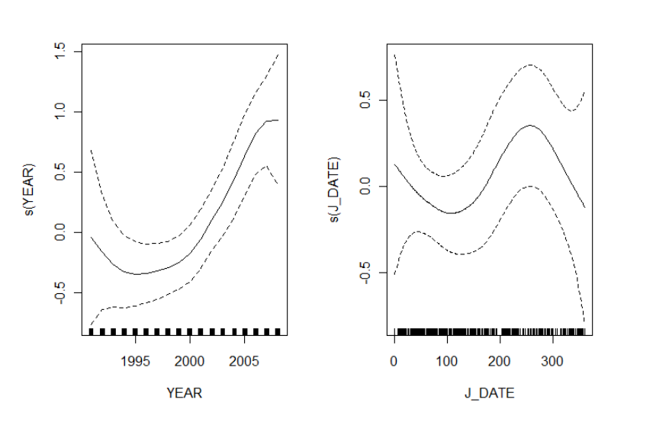
Fig. 8: ZINB GAMs for hake numbers in dolphin stomachs in relation to explanatory variables: smoother for significant effects of (a) Year of stranding and (b) Day of the year for the whole sample set.

